**Exercises**

**A.** Fill in the blanks with the correct form of **this** / **that**/ **these** / **those**, and the correct form of verb BE (**is / are**)

1. ________________________________ an old car. Resultado de imagen para a hand pointing picture 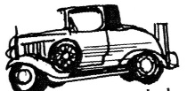
2. ________________________________ boots. Resultado de imagen para a hand pointing picture ……………………….………. 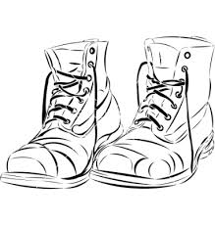
3. ________________________________ an apple. Resultado de imagen para a hand pointing picture
4. ________________________________ keys. Resultado de imagen para a hand pointing picture……………………………………..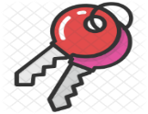

5. ________________________________ a ball. Resultado de imagen para a hand pointing picture …………………………………. 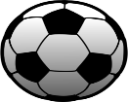

6. ________________________________books . Resultado de imagen para a hand pointing picture

**B.** Write questions using: **this** / **that**/ **these** / **those**, and the correct form of verb BE (**is / are**), then give complete answers using the pictures below. Look at the examples.

***Example***: - What is ***that***? - that’s a camera. Resultado de imagen para a hand pointing picture ………………………………….

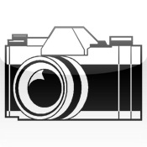

- What are ***these***? – These are students. Resultado de imagen para a hand pointing picture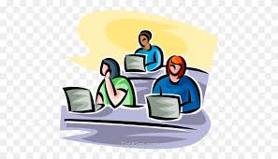

1. What ____________________________________? Resultado de imagen para a hand pointing picture ………………….

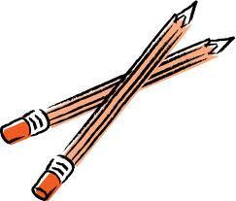

______________________________________________.

2. What _______________________________________? Resultado de imagen para a hand pointing picture ……………………

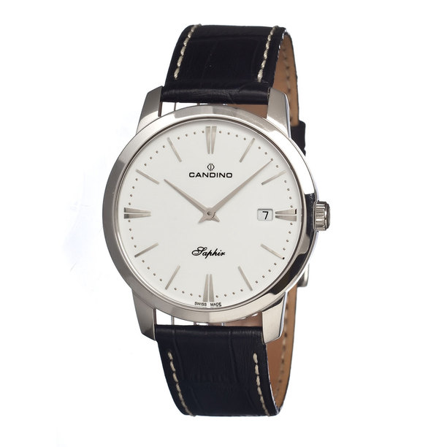

______________________________________________.

3. What _______________________________________? Resultado de imagen para a hand pointing picture

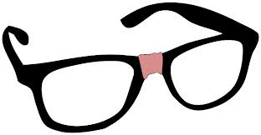

______________________________________________.

4. What _______________________________________? Resultado de imagen para a hand pointing picture 

______________________________________________.

**REMEMBER TO FOLLOW THE EXAMPLES!!!**